Lasting legacy brick wall! Buy a brick!
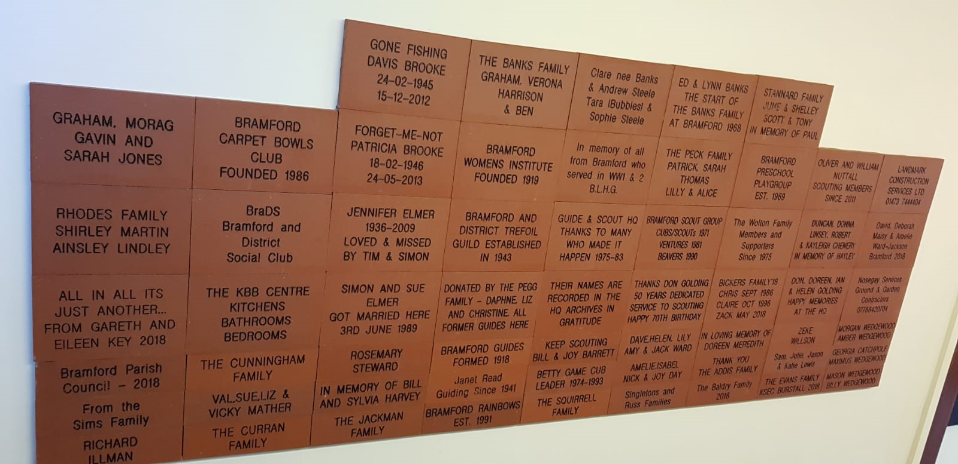
We are creating a Lasting Legacy Brick Wall in order to raise funds for some much-needed refurbishment work at the Bramford Guide & Scout HQ, including updating the toilets and kitchen. Past and present Guide & Scout members & their families and friends can buy an inscribed brick to go on a wall in the entrance hall to the HQ. Small bricks will be available for £30 each or larger bricks for £60. Great for your family name, in memory of someone, or for local businesses to advertise their services on.
………………………………………………………………………………………………………………………………………………………………………………………………………………………………………………………………………………….
I am interested in buying a brick!! Name ………………………………………………………………………
Contact phone number………………………………………………………………
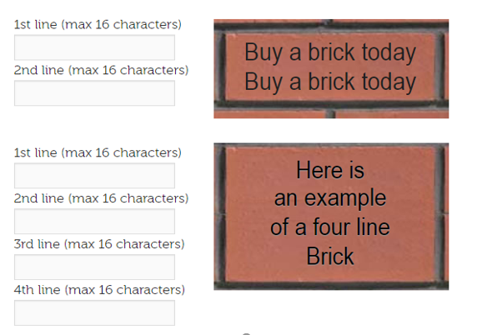
If you would like to purchase a brick, please fill in this form and return to your group or contact any of the following by 31st January 2019 : - G&SHQ - bramfordgandshq@gmail.com Sarah Peck - Sarah@kbbeastanglia.co.uk 07790506265 Claire Bickers - clairebickers28@googlemail.com 07576350296
Payment can be made via cheque made payable to Bramford Guide and Scout HQ or via BACS to Sort code 204451 Account 53856771 including your name as a reference.

