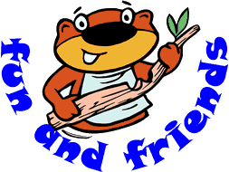

Beaver Code of Conduct
- Respect other people.
- Listen when a leader is speaking.
- When a leader raises their hand the group must be quiet.
- Follow the instructions given by leaders or other adults
- Wear their uniform smartly and with pride
- To be kind and look after all Beavers
- Good behaviour must be maintained at all times otherwise the yellow, amber & red procedure will come into force.
- To remember and keep the Beaver Scout Promise.

The Beaver Scout Promise
I promise to do my best
To be kind and helpful
And to love God.

The Beaver Scout Motto
Be prepared

Things we will not allow
Being mean to others
Bullying physical or verbal – name calling, threatening behaviour, putting people down will not be tolerated in
any way
Things that put you or others in danger
Shoving, pushing, wrestling, kicking or silly behaviour during activities can all be dangerous
Respect to property and equipment
Look after things and try not to break anything
Rudeness and swearing
This is not acceptable and offends many

Yellow, Amber and Red Warning Procedure
Yellow (1st Warning)
- Asked to sit out of activity for 5 minutes
Amber (2nd Warning)
- Informed that parents will be advised of not following code of conduct after Beaver Meeting
Red (3rd Warning)
Repeat of the same or similar behaviour
- Will be told that they will not be able to take part in the activity the following week.

