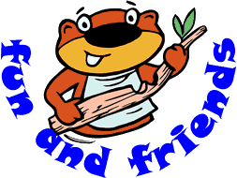
1st BRAMFORD SCOUT GROUP
BEHAVIOUR WE WILL NOT ALLOW
- Being mean to others
- Bullying physical or verbal – name calling, threatening behaviour, putting people down will not be tolerated in any way
- Things that put you or others in danger
- Shoving, pushing, wrestling, kicking or silly behaviour during activities can all be dangerous
- Lack of Respect to property and equipment
- Rudeness and swearing
This is not acceptable and offends many

More serious behaviour will result in a Yellow Card. You will be removed from the activity for a period of time.
Examples of this type of behaviour;
- Damaging of property due to being careless
- Arguing with or challenging a leader, parent helper or visitor
- Threatening/rude behaviour or language (not physical)
- Cheating during games
- Deliberate time wasting
- Telling lies or misleading others
- Continuous talking or disruption when a leader has asked for quiet
- Continuing with unacceptable or disruptive behaviour after being told to stop
- Continuous refusal to follow instructions or rules
- Shoving, pushing and wrestling
More serious behaviour will result in an instant Red Card; You will be requested not to attend section meetings for between 1 to 3 weeks to be decided by the leader.

Examples of this type of behaviour;
- Bullying or physical attacks on other members
- Deliberately damaging property or equipment
- Complaints from visitors or members of the public
- Deliberate defiance of clearly given instructions where safety is threatened
- Continually using bad language
- Behaviour which could cause concern for the safety of other members

